**Project Design Phase- II**

**Data Flow Diagram & User Stories**

|  |  |
| --- | --- |
| Date | 3 October 2022 |
| Team ID | PNT2022TMID47980 |
| Project Name | Industry-Specific Intelligent Fire Management  System |

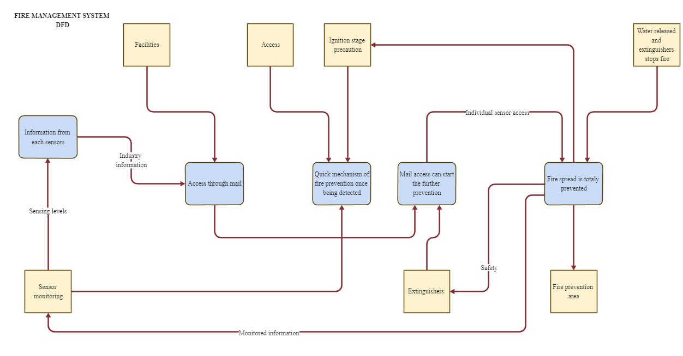

**User Stories**

|  |  |  |  |  |  |  |
| --- | --- | --- | --- | --- | --- | --- |
| **User Type** | **Functional requirement** | **User story**  **number** | **User story/task** | **Acceptance criteria** | **Priority** | **Release** |
| Customer  (Mobile user,  Web user,  Care executive,  Administrator) | Registration | USN-1 | As a user, I can register for the  application by entering my mail,  password, and  confirming my password | I can access my account/ dashboard | High | Sprint-1 |
|  |  | USN-2 | As a user, I will receive  confirmation  email once I have  registered for the application | I can receive confirmation  email & click confirm | High | Sprint-1 |
|  | Dashboard | USN-3 | As a user, I can register for the  application through internet | I can register  & access the dashboard  with Internet login | Low | Sprint-2 |
|  |  | USN-4 | As a user, I can register for the  application  through  Gmail | I can confirm the  registration in  Gmail | Medium | Sprint-1 |
|  | Login | USN-5 | As a user, I can log into the  application by entering email & password | I can login with my id and password | High | Sprint-1 |